[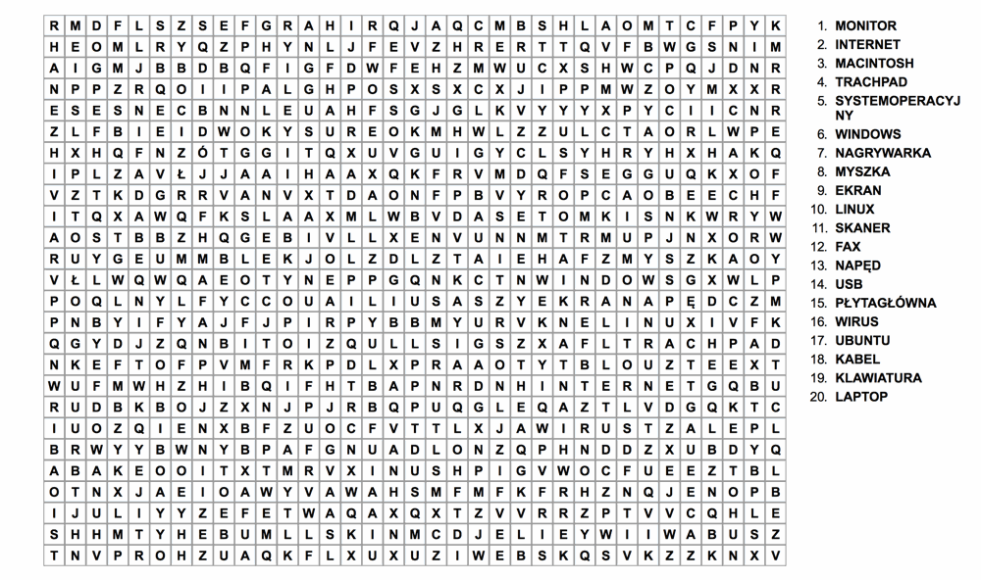](https://www.google.pl/url?sa=i&url=https://www.pinterest.se/pin/738308932639894596/&psig=AOvVaw1BuSyaBZq7JshtNdj2-2ZL&ust=1587142320225000&source=images&cd=vfe&ved=0CAIQjRxqFwoTCJDOoYe07egCFQAAAAAdAAAAABBN)