[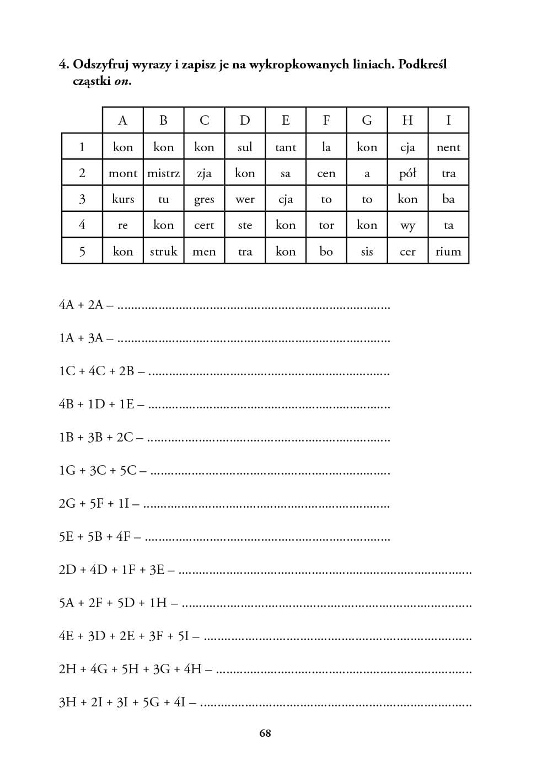](https://www.google.pl/url?sa=i&url=https://harmonia.edu.pl/pl/p/CWICZENIA-Z-A-E,-DZ-DZDZ,-EM,-EN,-OM,-ON-.../1697&psig=AOvVaw28IHVkRgOqJGKLIdgBpgAX&ust=1585143067688000&source=images&cd=vfe&ved=0CAIQjRxqFwoTCKDn2KGcs-gCFQAAAAAdAAAAABAZ)